**TASK 17 – DOCKERIZED NGINX SERVICE FOR STATIC WEB PAGE**

**What is a Dockerfile?**

A Dockerfile is a text file containing instructions used to assemble a Docker image. It automates the process of setting up an environment for your application by specifying:

* The base image.
* Configuration and installation steps.
* Environment variables, ports, and file copies.

**Key Dockerfile Attributes**

* **FROM**: Specifies the base image for building the custom image.
* **LABEL**: Adds metadata to the image, such as the maintainer's details or version.
* **EXPOSE**: Documents the ports the container listens on.
* **ENTRYPOINT**: Defines the default executable when the container starts.
* **CMD**: Provides default arguments for the ENTRYPOINT command.
* **COPY**: Copies files/directories from the host to the container.
* **VOLUME**: Specifies directories that should be persisted on the host or shared with other containers.

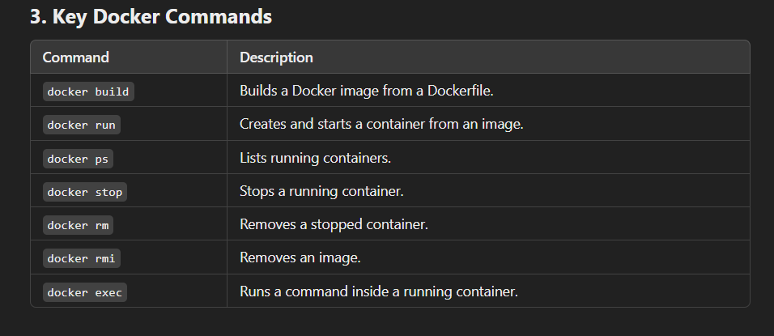

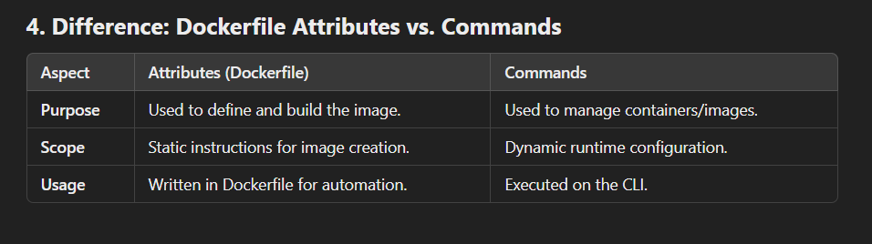

LAUNCH AN INSTANCE INSTALL DOCKER ADD EC2-USER TO DOCKER USER-GROUP

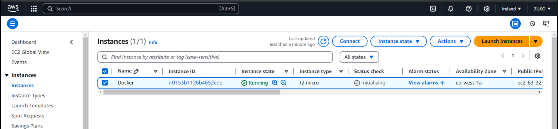

Adding ec2-user to a user group using the usermod command means you're modifying the user account (ec2-user in this case) to add it to an existing group. This action allows ec2-user to inherit the permissions and access rights of that group.

PULLED NGINX IMAGE FROM DOCKERHUB AND CREATED Dockerfile.

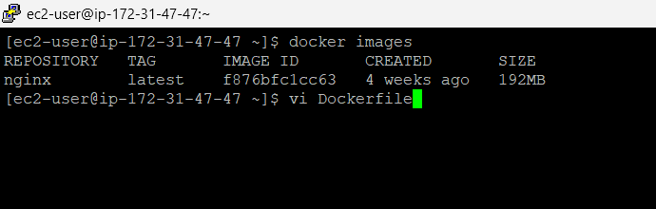

CUSTOMIZING IMAGES USING DOCKERFILE(ATTRIBUTES)

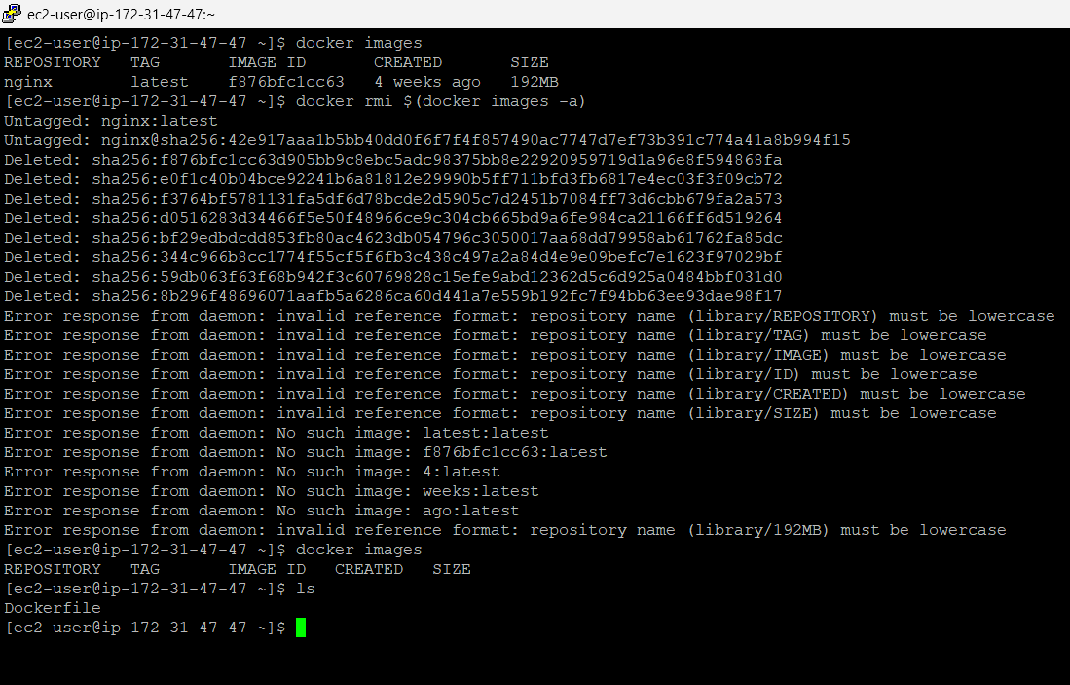

BUILDING THE CUSTOM IMAGE

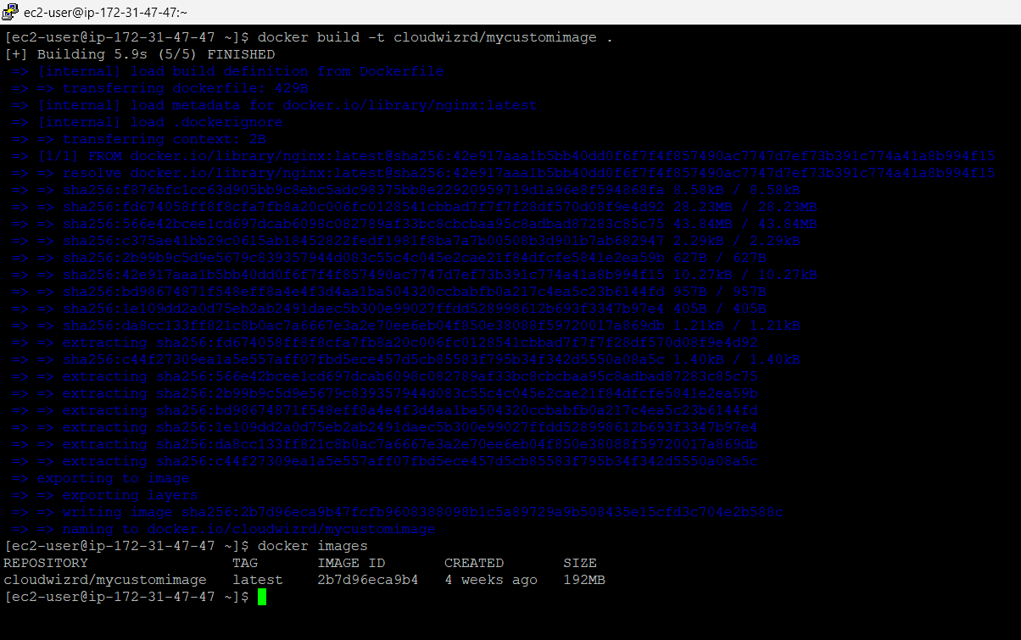

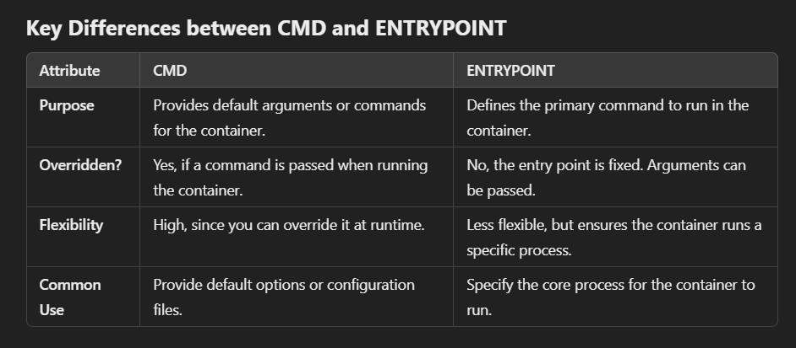

• **CMD**: Used to define default behaviour (can be overridden).

• **ENTRYPOINT**: Defines the core command (usually cannot be overridden).

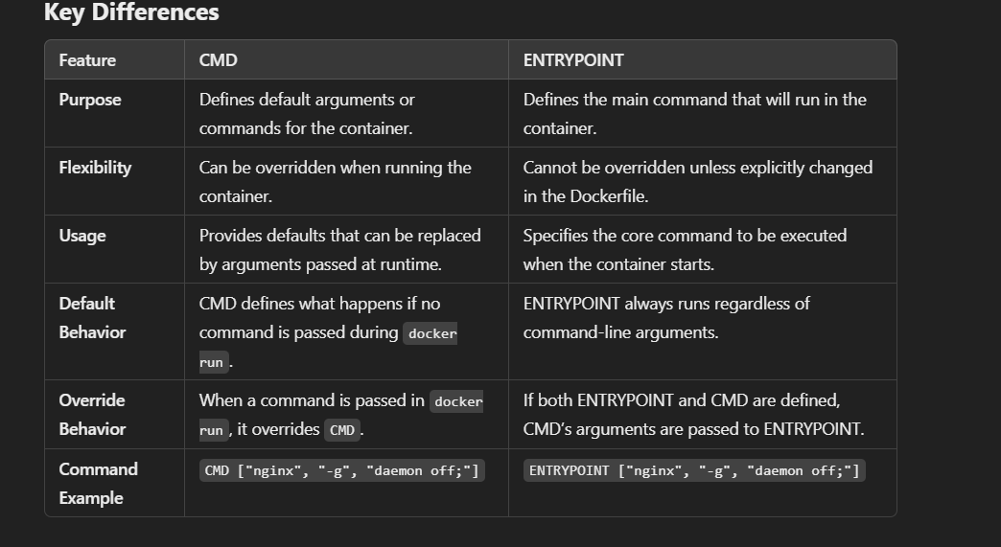

CREATED CONTAINER USING MY CUSTOM IMAGE

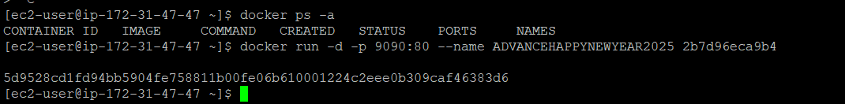

EDITING INBOUND RULES OPENING 9090 PORT

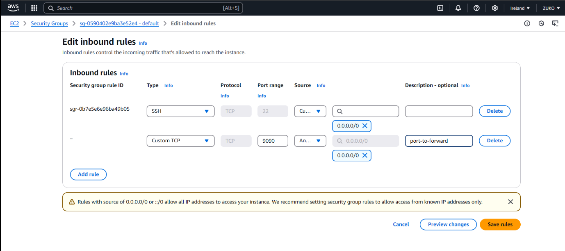

OUTPUT

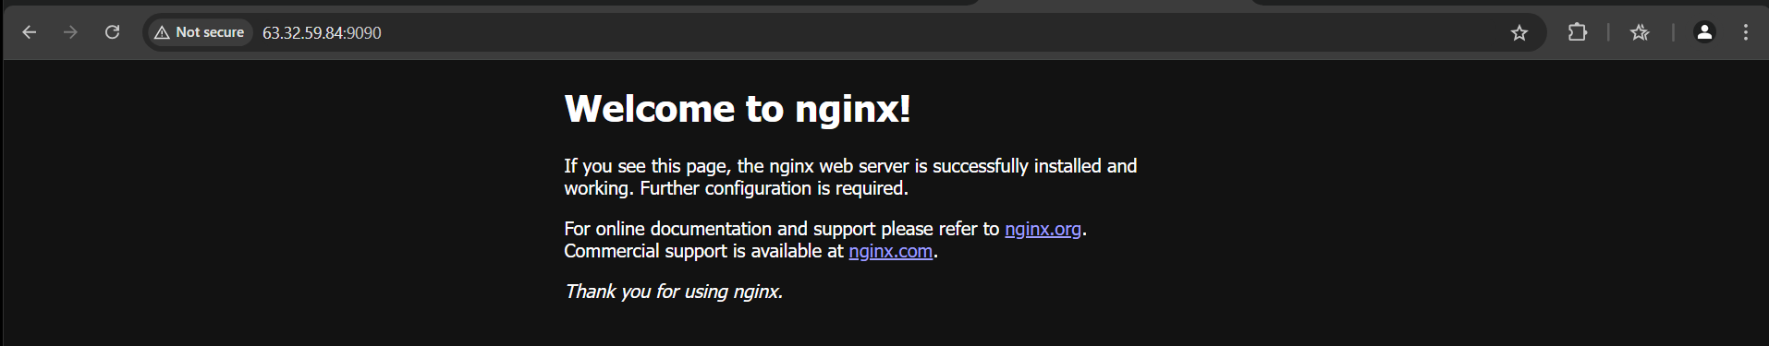

CREATING AN INDEX.HTML FILE AND USING COPY/VOMUME ATTRIBUTES

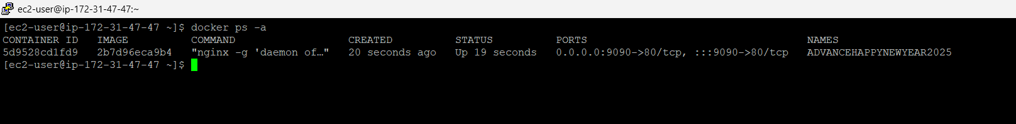

INDEX.HTML FILE

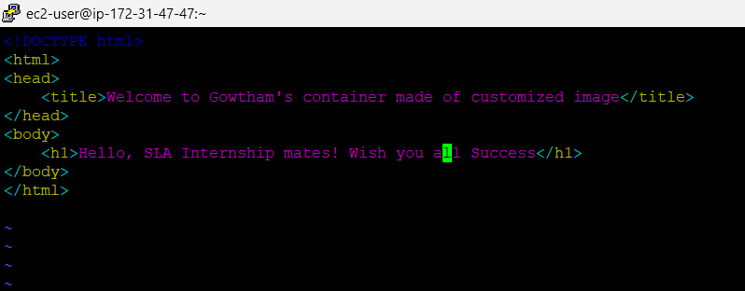

EDITING DOCKERFILE

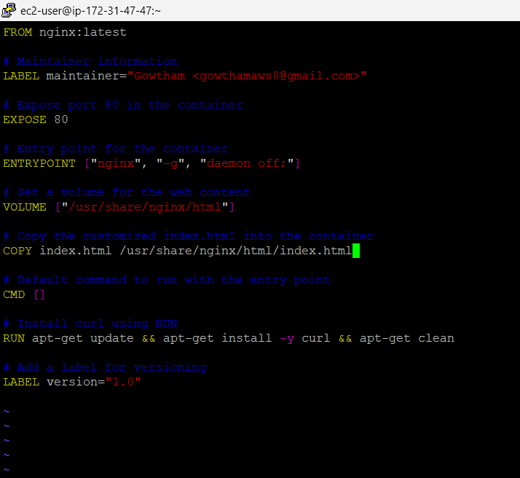

DELETING OLD CONTAINER TO FREE PORT 9090 AND BUILDING AGAIN

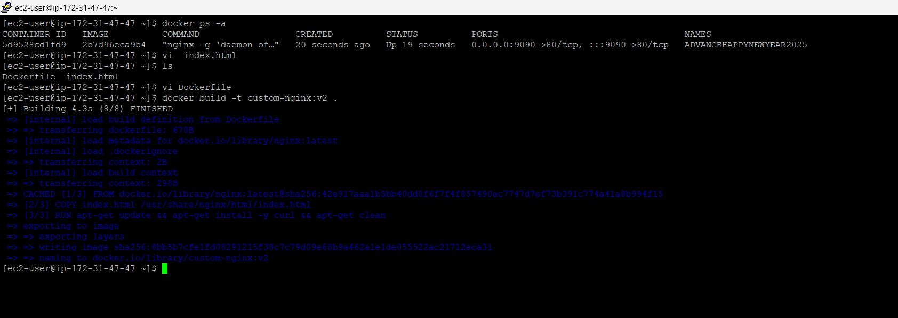

FORCED CUSTOM INDEX SERVER

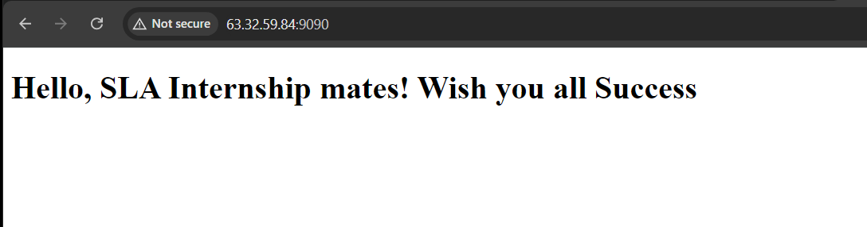

* **ENTRYPOINT** is used to define the main command (in this case, Nginx).
* **CMD** can be used to provide default arguments, but in this case, you don't necessarily need it unless you're configuring additional parameters.
* By using **ENTRYPOINT** for Nginx, you've essentially "forced" the container to always serve your index.html when it starts.

If you had ENTRYPOINT configured for the purpose of showcasing your index.html, then I am forcing the container to always run the web server and serve your content.